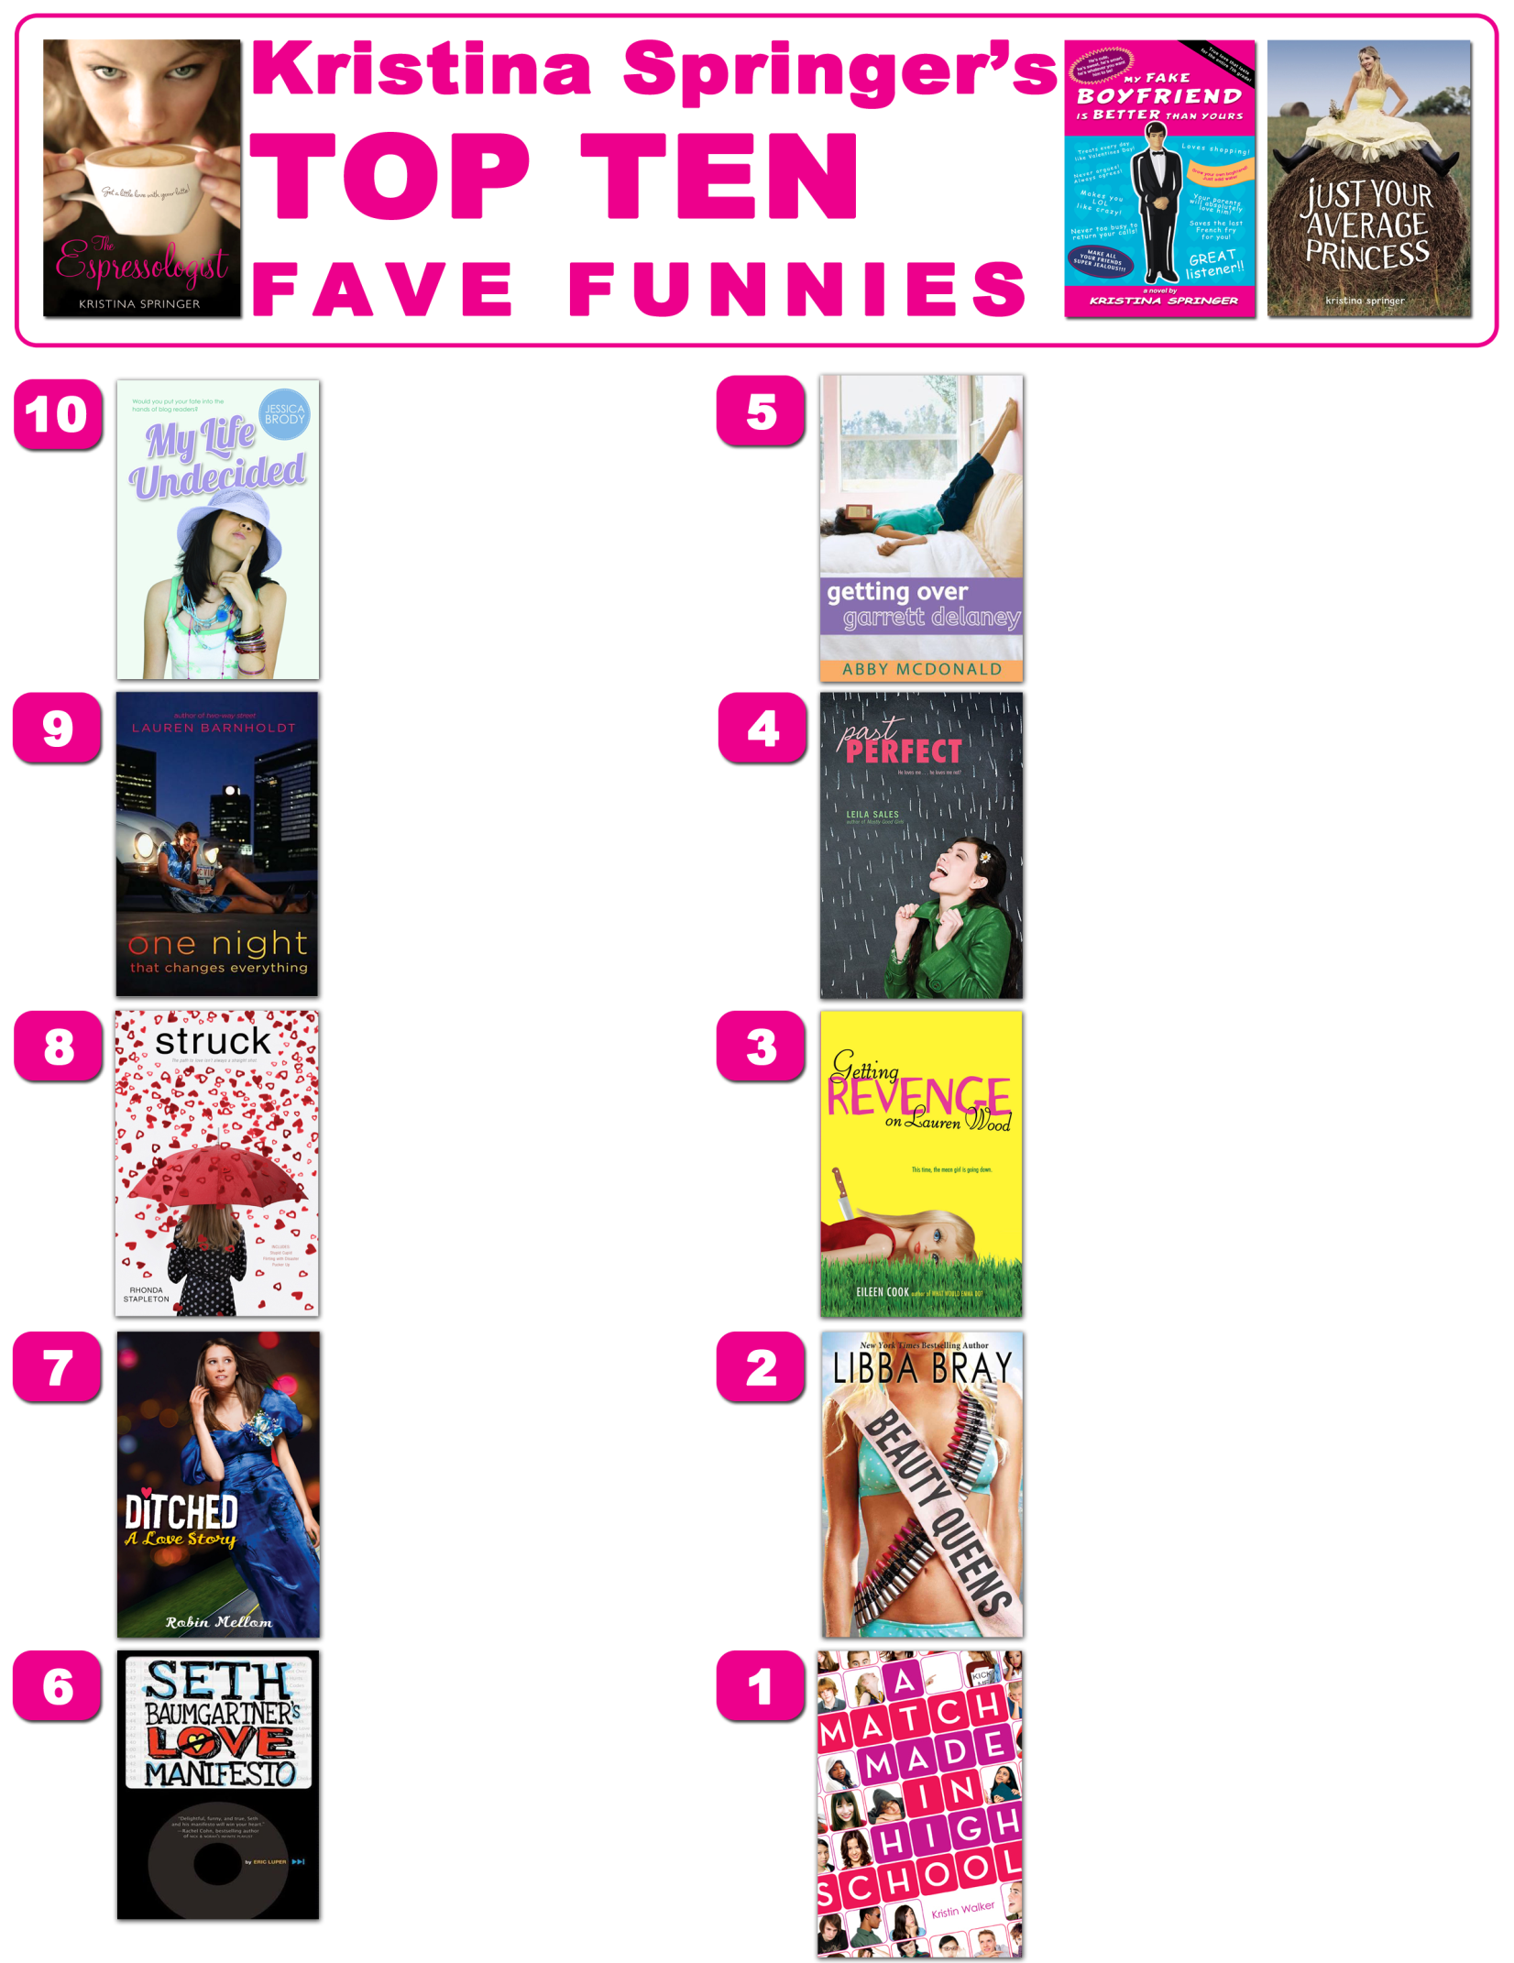

www.KristinaSpringer.com

Newly dumped guy starts popular anti-love podcast.

Teen beauty queens stranded on an island after a plane crash.

Girl sets on getting revenge on former friend who framed her three years earlier.

Girl wakes up in a ditch after prom and has to try to figure out how she got there.

Girl gets job at a matchmaking company with real life cupids.

Girl’s ex steals her list of goals and fears and won’t give it back until she does everything on the list.

Seniors forced to do a year-long marriage education course.

Girl from colonial reenactment village falls for boy from enemy civil war reenactment village.

Girl hopelessly in love with best friend decides she has to get over him and goes through detox.

Girl lets her blog readers decide every move from what book to read, to whom to date.